**Practical no 1**

A . Write a Mongodb Query to create,display and drop a database?



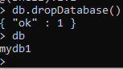

B. Write a Mongodb Query to create,display and drop a Collection?

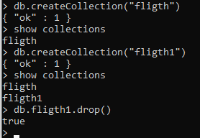

\

C. Write a Mongodb Query to Insert documents into the Collection? (insertOne,insertMany)

InsertOne

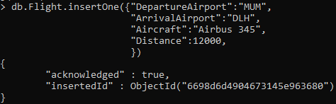

InsertMany

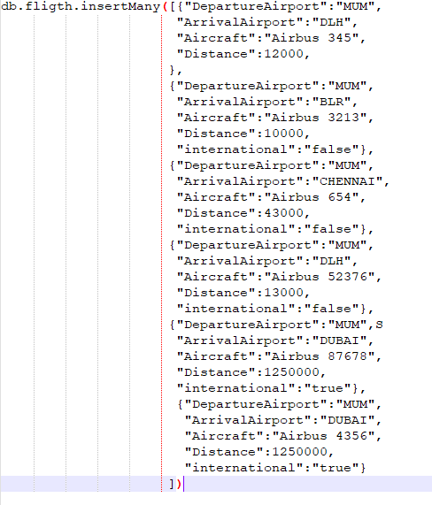

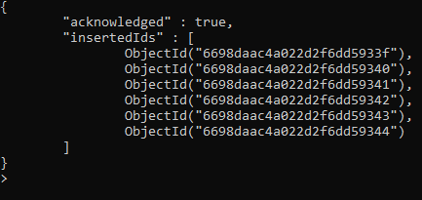

D.write a MongoDb query to retrieve a data from document (find,findone)?

findOne

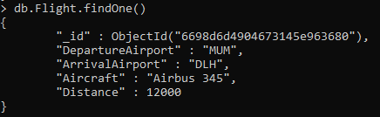

find

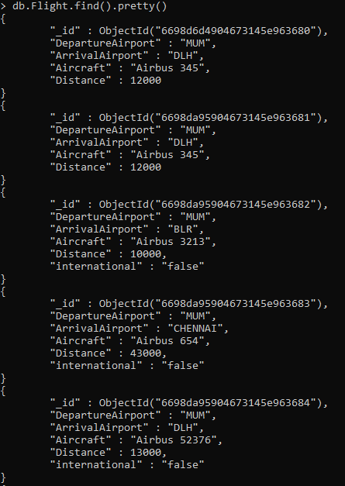

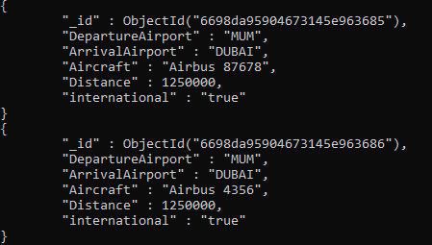

E.Write a mongoBd query to update the Document (update one , updatemnay)

updateOne



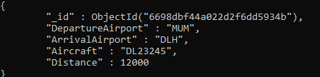

updateMany



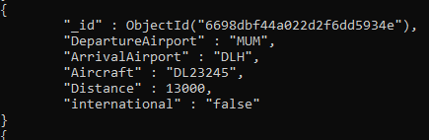

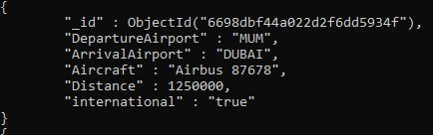

F.Write a mongoBd query to Delete the Document(deleteOne,DeleteMany)

deleteOne



deleteMany



Practical 2 :- Simple Queries with MongoDB

1) Create a collection named users with a few documents in it (as per the text file attached )

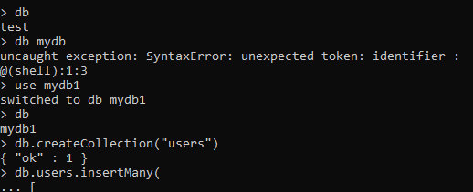

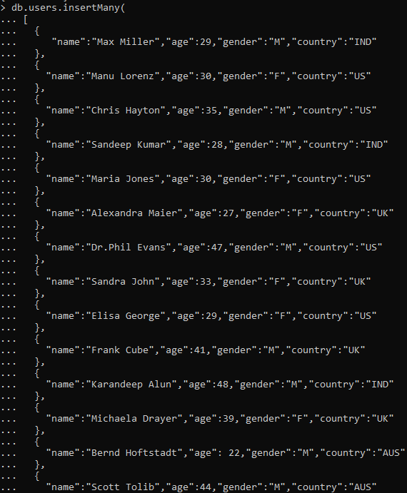

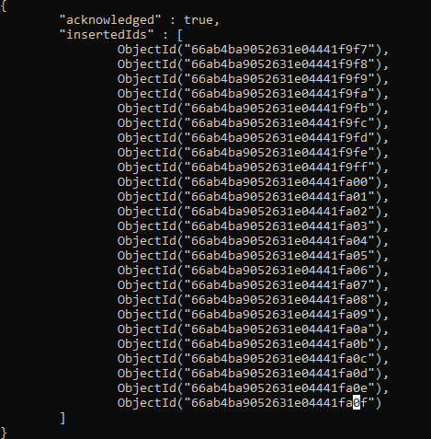

2) List all the documents in users collection

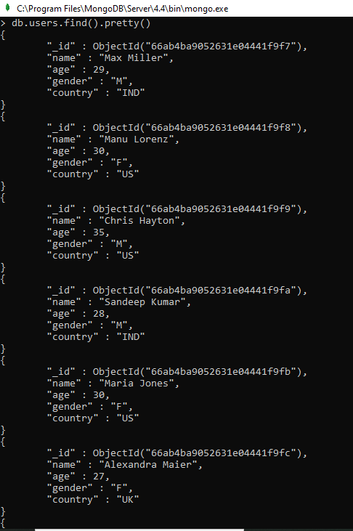

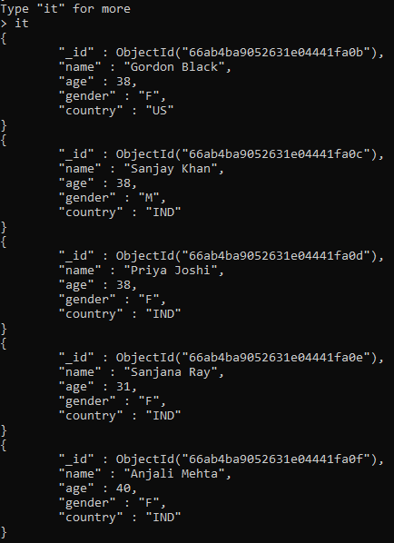

3) Selector

Fetch all the Indian and US users from the list

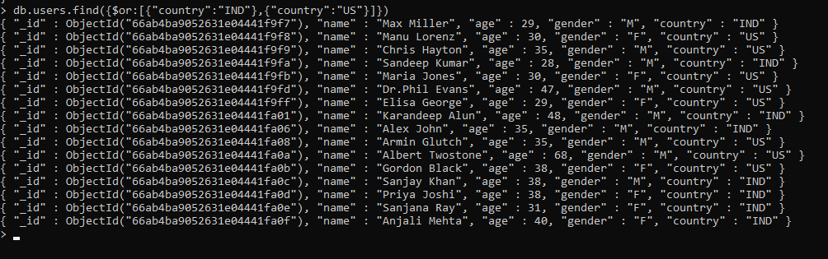

Fetch all the Indian and US females from the list

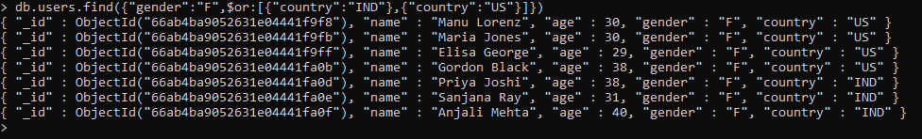

4) Projector

Fetch the name and age of all male users

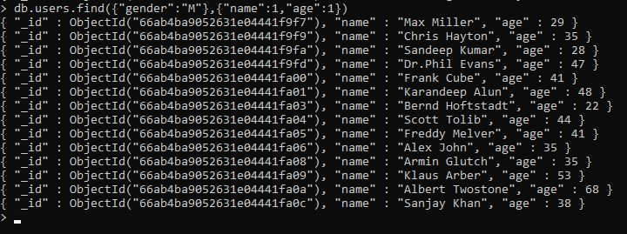

5) sort()

Fetch the name and age of all male users in ascending order of age

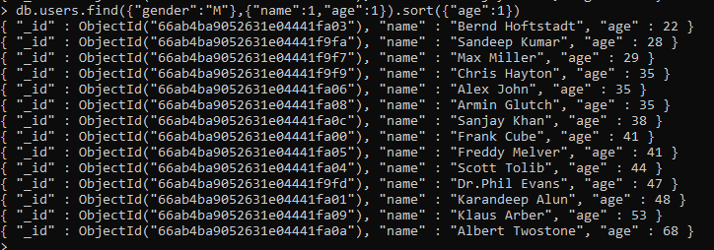

Fetch the name and age of all male users in descending order of name and ascending order of age

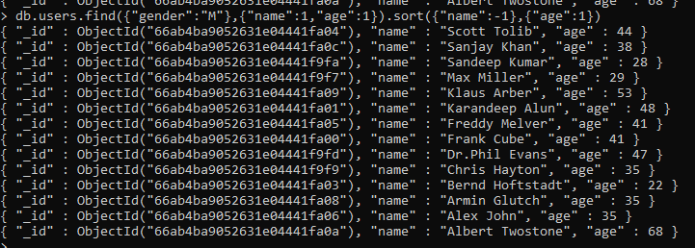

6) limit()

Fetch the first 5 male users

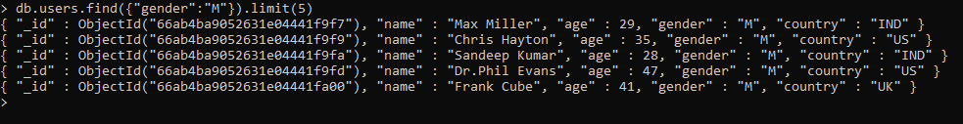

7) skip()

Fetch the male users from India. Skip the first two records and list the next three records



8) count()

Count the total number of users



9) explain()

10) Conditional Operators

List all male users whose age is less than 45

List all female users whose age is greater than or equal to 40

List all users from India and Australia

List all users who are not from US or India

11) Indexes

Single Key Index

Compound Key Index

View index

Delete index

Prcatical 3

1) explain()

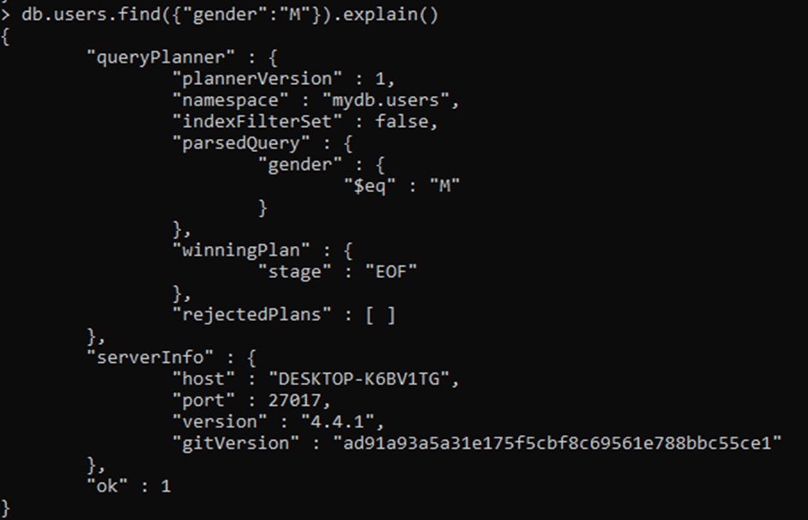

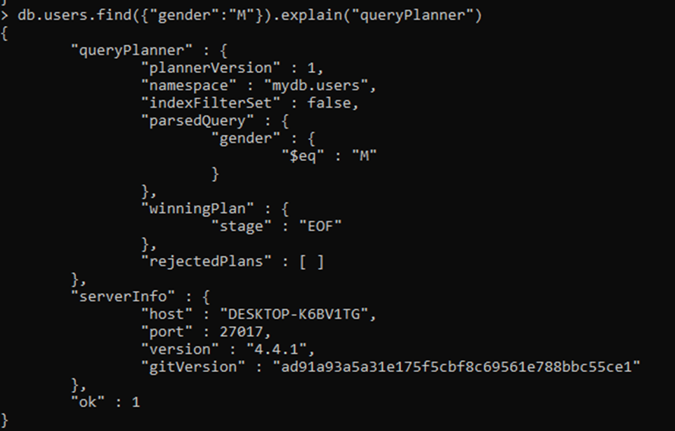

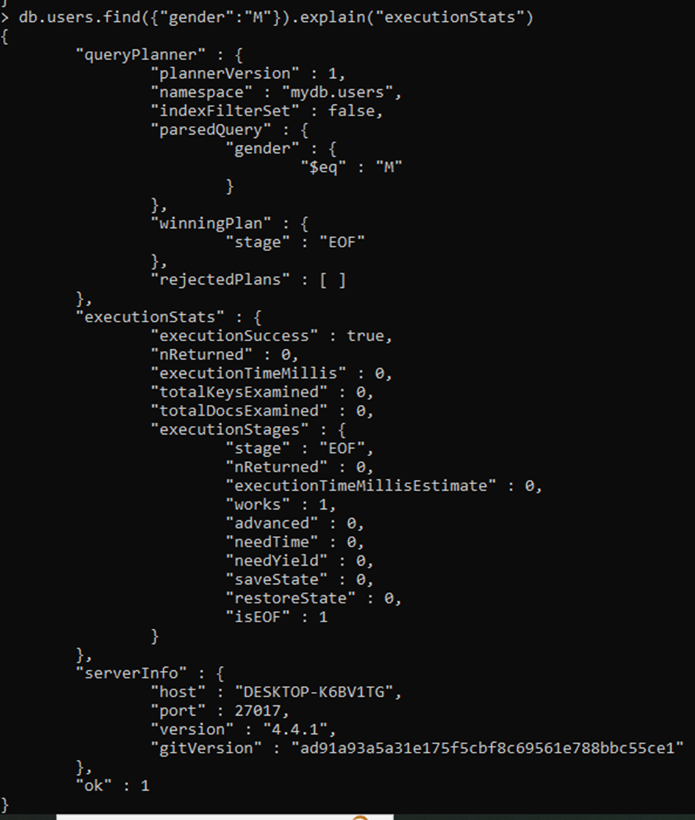

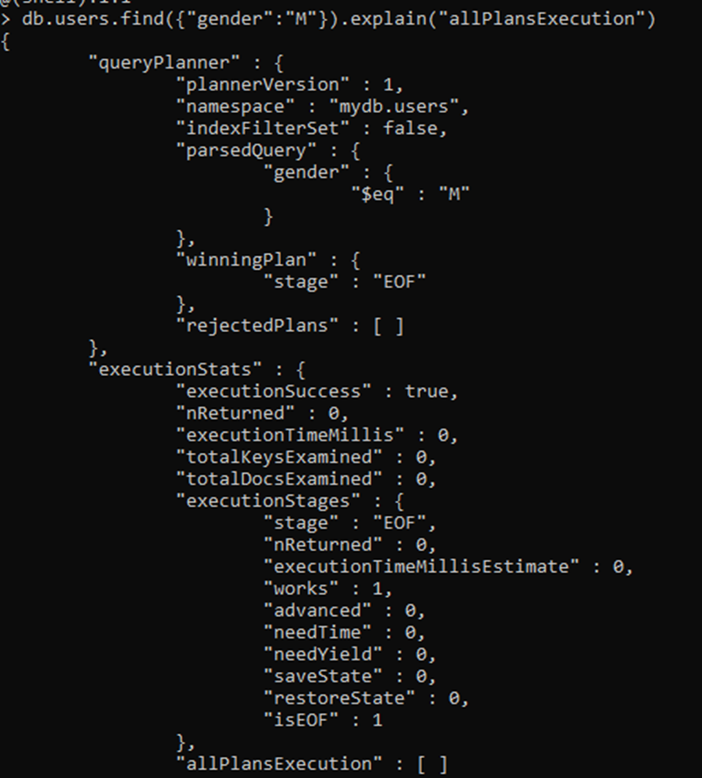

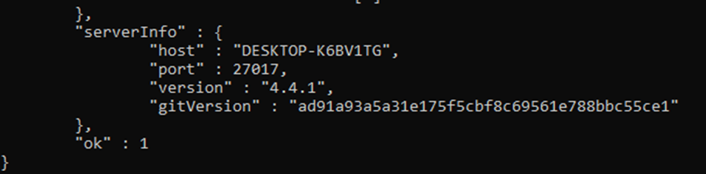

2) Conditional Operators

List all male users whose age is less than 45

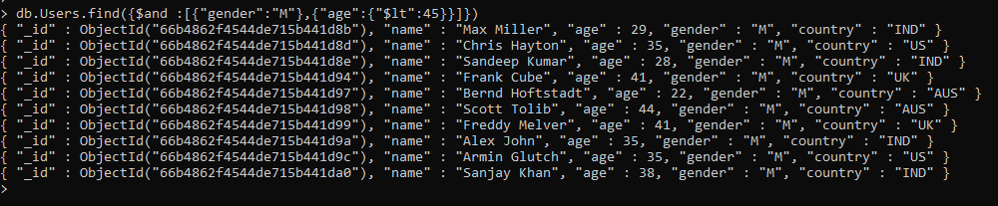

List all female users whose age is greater than or equal to 40



List all users from India and Australia

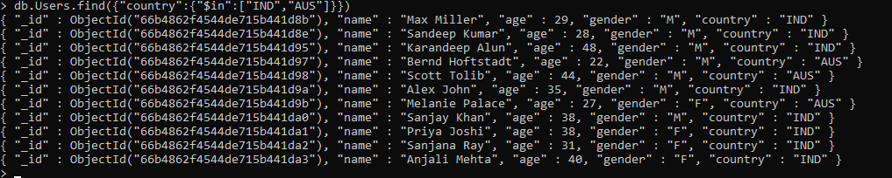

List all users who are not from US or India

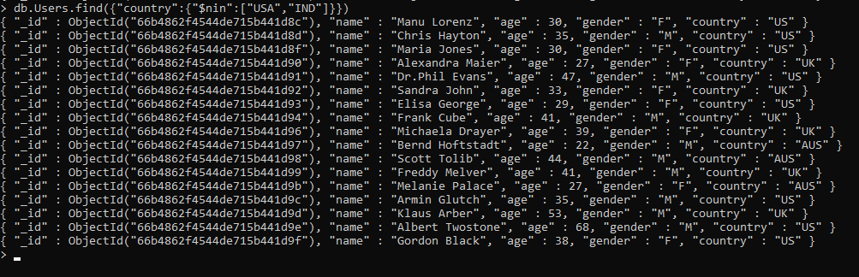

3) Indexes

Single Key Index

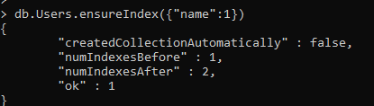

Compound Key Index

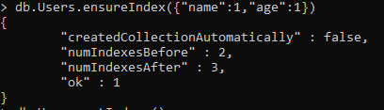

View index

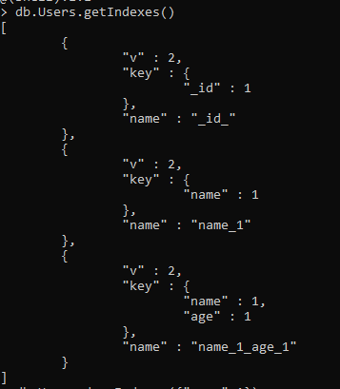

Delete index

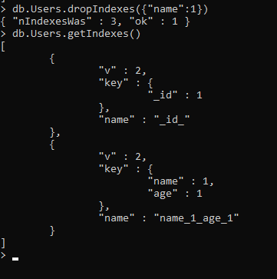

4) Write a Mongodb query to use sum , average , max and min expression

Sum:

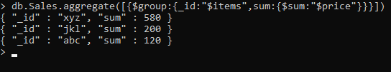

Average:

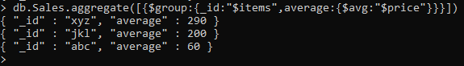

Max:

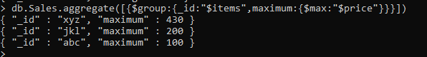

Min:

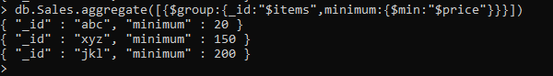

5) Write a mongodb query to use first and last expression

First:

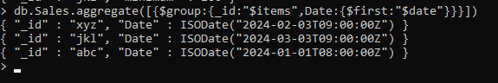

Last:

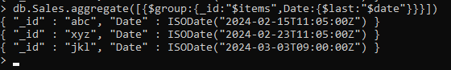

Practical 4

J query selectors

1.Element name selector

Code:

<html>

    <head>

        <title>The selector Example</title>

            <script type="text/javascript" src="jquery-3.7.1.min.js"></script>

            <script type="text/javascript" language="javascript" >

                $(document).ready(function(){

                    $("div").css("background-color","yellow");

                });

            </script>

    </head>

    <body>

        <div class="big" id="div1">

            <p>This is first division of the DOM.</p>

        </div>

        <div class="medium" id="div2">

            <p>This is second division of the DOM.</p>

        </div>

        <div class="big" id="div3">

            <p>This is third division of the DOM.</p>

        </div>

    </body>

</html>

Output:

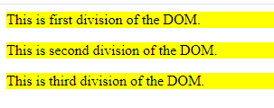

2.Element Id selector

Code:

<html>

    <head>

        <title>The selector Example</title>

            <script type="text/javascript" src="jquery-3.7.1.min.js"></script>

            <script type="text/javascript" language="javascript" >

                $(document).ready(function(){

                    $("#div2").css("background-color","yellow");

                });

            </script>

    </head>

    <body>

        <div class="big" id="div1">

            <p>This is first division of the DOM.</p>

        </div>

        <div class="medium" id="div2">

            <p>This is second division of the DOM.</p>

        </div>

        <div class="big" id="div3">

            <p>This is third division of the DOM.</p>

        </div>

    </body>

</html>

Output:

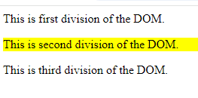

3.Element class selector

Code:

<html>

    <head>

        <title>The selector Example</title>

            <script type="text/javascript" src="jquery-3.7.1.min.js"></script>

            <script type="text/javascript" language="javascript" >

                $(document).ready(function(){

                    $(".big").css("background-color","yellow");

                });

            </script>

    </head>

    <body>

        <div class="big" id="div1">

            <p>This is first division of the DOM.</p>

        </div>

        <div class="medium" id="div2">

            <p>This is second division of the DOM.</p>

        </div>

        <div class="small" id="div3">

            <p>This is third division of the DOM.</p>

        </div>

    </body>

</html>

Output:

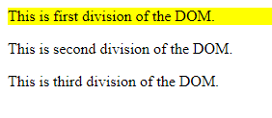

4.Universal selector

Code:

<html>

    <head>

        <title>The selector Example</title>

            <script type="text/javascript" src="jquery-3.7.1.min.js"></script>

            <script type="text/javascript" language="javascript" >

                $(document).ready(function(){

                    $("*").css("background-color","yellow");

                });

            </script>

    </head>

    <body>

        <div class="big" id="div1">

            <p>This is first division of the DOM.</p>

        </div>

        <div class="medium" id="div2">

            <p>This is second division of the DOM.</p>

        </div>

        <div class="small" id="div3">

            <p>This is third division of the DOM.</p>

        </div>

    </body>

</html>

Output:

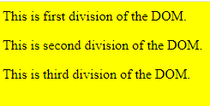

5.Multiple Element selector

Code:

<html>

    <head>

        <title>The selector Example</title>

            <script type="text/javascript" src="jquery-3.7.1.min.js"></script>

            <script type="text/javascript" language="javascript" >

                $(document).ready(function(){

                    $(".big,#div3").css("background-color","yellow");

                });

            </script>

    </head>

    <body>

        <div class="big" id="div1">

            <p>This is first division of the DOM.</p>

        </div>

        <div class="medium" id="div2">

            <p>This is second division of the DOM.</p>

        </div>

        <div class="small" id="div3">

            <p>This is third division of the DOM.</p>

        </div>

    </body>

</html>

Output:

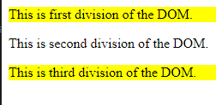

**Practical No. 5 – Click and Double Click Event**

1. **Click Event**

**Click.html :-**

<html>

<head>

<title> Click Event </title>

<script type = "text/javascript" src = "jquery-3.7.1.min.js"></script>

<script type = "text/javascript" src = "app.js"></script>

<link rel = "stylesheet" type = "text/css" href = "style.css"/>

</head>

<body>

<p> Click on any square below</p>

<div class = "div" style = "background-color:blue;">ONE</div>

<div class = "div" style = "background-color:green;">TWO</div>

<div class = "div" style = "background-color:red;">THREE</div>

</body>

</html>

**app.js :-**

$(document).ready(function(){

$("div").click(function()

{alert('Event type is : '+event.type);

alert('The Button clicked is :'+event.target.innerHTML);});

});

**style.css :-**

.div{margin:10px;

padding:12px;

border:2px;

width:60px;

height:60px;

}

**Output :-**

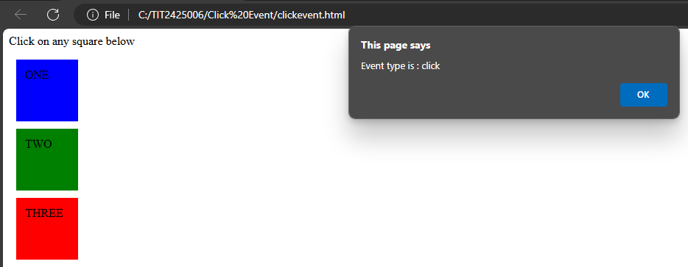

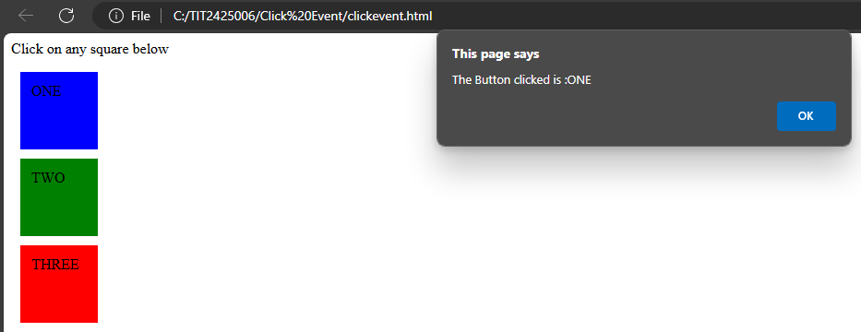

1. **Double Click Event**

**dblClick.html :-**

<html>

<head>

<title> Click Event </title>

<script type = "text/javascript" src = "jquery-3.7.1.min.js"></script>

<script type = "text/javascript" src = "app.js"></script>

<link rel = "stylesheet" type = "text/css" href = "style.css"/>

</head>

<body>

<p>Double Click on any square below</p>

<div class = "div" style = "background-color:blue;">ONE</div>

<div class = "div" style = "background-color:green;">TWO</div>

<div class = "div" style = "background-color:red;">THREE</div>

</body>

</html>

**app.js :-**

$(document).ready(function(){

$("div").dblclick(function(){

$(this).hide();

});

});

**style.css :-**

.div{margin:10px;

padding:12px;

border:2px;

width:60px;

height:60px;

}

**Output :-**

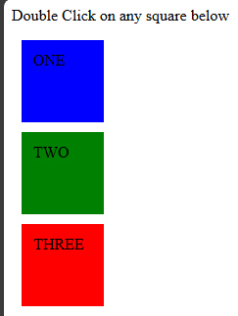

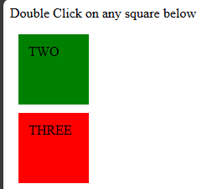

**Practical No. 6 – Fading Effect and Sliding Effect**

1. **Fading Effect**

**Fading.html :-**

<html>

<head>

<title>Fading Effect</title>

<script type="text/javascript" src="jquery-3.7.1.min.js"></script>

<script type="text/javascript" src="app.js"></script>

<link rel="stylesheet" type="text/css" href="style.css"/>

</head>

<body>

<p>Click on any of the buttons</p>

<button id = "out"> FADE OUT </button>

<button id = "in"> FADE IN </button>

<div class = "pic"> <img src = "sies125.jpeg" alt="jQuery" /></div>

<div class = "log"></div>

</body>

</html

**app.js :-**

$(document).ready(function(){

$("#in").click(function()

{$(".pic").fadeIn('slow',function(){

$(".log").text("Fade in Transition Complete");

});

});

$("#out").click(function()

{$(".pic").fadeOut('slow',function(){

$(".log").text("Fade out Transition Complete");

});

});

});

**style.css :-**

p{background-color:blue;

width:200px;

border:1px solid;

}

img{height:150px;

width:150px;

}

**Output :-**



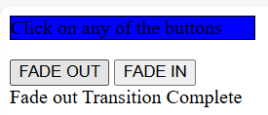

1. **Sliding Effect**

**Sliding.html :-**

<html>

<head>

<title>Sliding Effect</title>

<script type="text/javascript" src="jquery-3.7.1.min.js"></script>

<script type="text/javascript" src="app.js"></script>

<link rel="stylesheet" type="text/css" href="style.css"/>

</head>

<body>

<p>Click on any of the buttons</p>

<button id = "up"> ScaleUp </button>

<button id = "down"> ScaleDown </button>

<div class = "pic"> <img src = "sies125.jpeg" alt="jQuery" /></div>

<div class = "log"></div>

</body>

</html

**app.js :-**

$(document).ready(function(){

$("#up").click(function()

{$(".pic").slideUp('slow',function(){

$(".log").text("Slide Up Transition Complete");

});

});

$("#down").click(function()

{$(".pic").slideDown('slow',function(){

$(".log").text("Slide Down Transition Complete");

});

});

});

**style.css :-**

p{background-color:blue;

width:200px;

border:1px solid;

}

img{height:150px;

width:150px;

}

**Output :-**

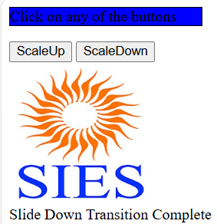

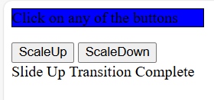

**Practical No. 7 – Animation Effect and Chaining Effect**

1. **Animation Effect**

**Animation.html :-**

<html>

<head>

<title>Animation Effect</title>

<script type="text/javascript" src="jquery-3.7.1.min.js"></script>

<script type="text/javascript" src="app.js"></script>

</head>

<body>

<button> START ANIMATION</button>

<div style="background:blue; height:100px;

Width:100px; Position:absolute;"> ANIMATION EFFECT

</div>

</body>

</html>

**app.js :-**

$(document).ready(function() {

$("button").click(function()

{$("div").animate({left:'250px'},"slow");

$("div").animate({height:'500px'},"slow");

$("div").animate({width:'300px'},"slow");

$("div").animate({fontSize: '50px'},"slow");

});

});

**Output :-**

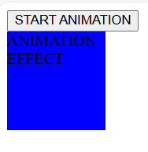

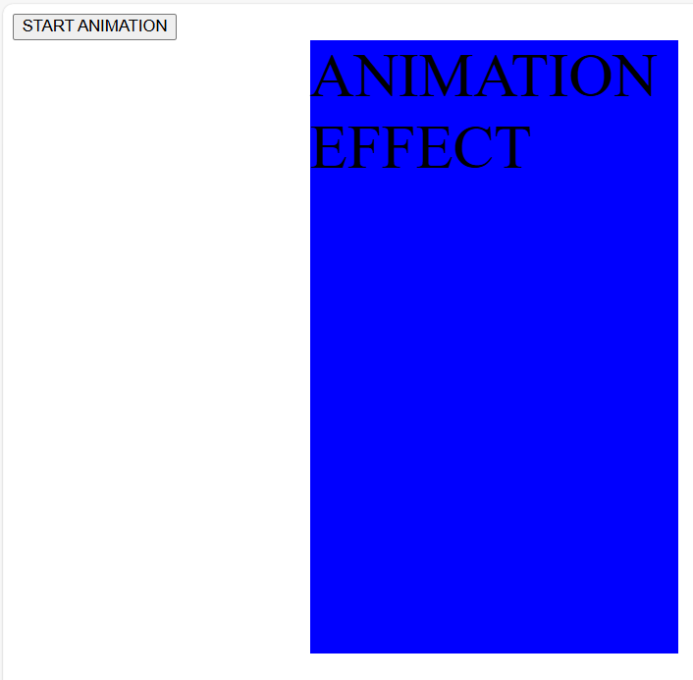

1. **Chaining Effect**

**Chaining.html :-**

<html>

<head>

<title>Chaining Effect</title>

<script type=”text/javascript” src=”jquery-3.7.1.min.js”></script>

<script type=”text/javascript” src=”app.js”></script>

</head>

<body>

<p id=”txt”>THIS IS CHAINING IN JQUERY!!!</p>

<button> CLICK FOR EFFECTS</button>

</body>

</html>

**app.js :-**

$(document).ready(function() {

$(“button”).click(function()

{$(“#txt”).css(“color”,”red”).slideUp(1000).slideDown(3000).fadeOut(3000).fadeIn(3000);

});

});

**Output :-**

